Student Achievement and Retention Rates Dashboard – Design and Strategy

Contents

# Introduction

# Dashboard Design Principles

## Student Achievement Rates

## Student Retention Rates

## Leavers, Achievement, and Retention Trends

## Dashboard Performance

# Accessibility

## Perceivable

## Operable

## Understandable

## Robust

# Conclusion

# References

# Appendix

# Introduction

This report provides a comprehensive overview of the design principles and approach used in creating the ‘Student Achievement and Retention Rates’ dashboard. The dashboard was developed for use by relevant stakeholders of a UK further education (FE) provider, to convey data insights pertaining to student achievements and retention. Accordingly, the report details the methodology behind the dashboard’s design in this context.

# Dashboard Design Principles

The dashboard was developed in Microsoft Power BI, the market leader in business intelligence software (Fay, et al., 2024). As the college utilises this tool for other data dashboards, it will be familiar to the users and integrate seamlessly with the college’s other Microsoft platforms. Three pages were created for this dashboard:

1. Student Achievement Rates (figure 1): Compares student achievement rates to the college key performance indicator.
2. Student Retention Rates (figure 2): Compares student retention rates to the college key performance indicator.
3. Leavers, Achievement, and Retention Trends (figure 3): Shows the changes in leavers, achievement, and retention throughout the academic years.

## Student Achievement Rates

To represent the college’s student achievement performance, the most significant metrics were displayed as large cards at the top of the page (figure 1). This ensures that the most important information is read first, since UK audiences generally read from top-left to bottom-right. The order of the cards was also selected to convey the data story of student achievements in a logical flow from left to right:

1. Total Leavers – 'How many learners completed their education?'
2. Total Achievers – 'How many leavers successfully achieved their qualification?'
3. Achievement% – 'What does this make the overall achievement rate?'
4. Achievement% Target – 'What is the college’s target KPI for achievement?'
5. Difference to Target – 'How does the college's achievement rate compare to the target?'

This presentation of achievement rates should be effective for strategic audiences, including the Governing Body, who are primarily interested in high-level performance metrics.

A bar chart was employed to aggregate achievement rates by sector subject area (figure 4). Horizontal orientation was chosen to allow the subject areas to display in their entirety. The bars were ordered by ‘Achievement%’ in descending order, ranking subject areas by performance, though users have the option to re-sort the chart if needed. This facilitates easy comparison between subject areas.

A dotted line representing the achievement KPI was included to indicate which areas meet the target. Additionally, tooltips were enabled, allowing users to see precise achievement metrics for each subject area by simply hovering over them (figure 4). The ability to drilldown on specific subject areas was also included (figure 4). The design of this chart should allow analytical users, such as the Reporting Team, to retrieve detailed data insights on achievements for specific subject areas.

The ‘Achievement% by Qualification Level’ bar chart (figure 1) was created with the same design principles as the ‘Achievement% by Sector Subject Area’ chart, except it is orientated vertically. This is to distinguish it from the other chart on the dashboard page, and because its labels are much shorter. Since there are only five qualification level categories, the bars are ordered by level instead, so that the sorting is more meaningful.

The bar graphs and ‘Difference to Target’ card also incorporate conditional formatting colours (figure 1). This is another visual cue, helping users identify which areas of the college exceed the achievement KPI (dark blue) or fall short of the target (orange).

The final visual on this page is the ‘Total Achievers by Age Group’ chart (figure 5). A donut chart was chosen for this visualisation as there are only two categories, making it easy to compare the proportions between the two slices. However, since similarly sized slices can be difficult to differentiate in pie or donut charts (Siirtola, 2019), data labels were added to display the percentages. This chart could be particularly useful for college stakeholders responsible for specific age groups, as they can select a slice to filter the entire dashboard and view achievement insights relevant to their student cohort.

## Student Retention Rates

This page replicates the design of the ‘Student Achievement Rates’ page, but instead displays student retention metrics. This is by design so that it is easier for the users to become familiar with both dashboard pages.

## Leavers, Achievement, and Retention Trends

A combination line chart was utilised on this dashboard page, with leavers plotted on the left y-axis and ‘Achievement%’ and ‘Retention%’ on the right y-axis (figure 3). Displaying all three metrics as lines on the same chart allows for easy comparison of changes over time between the three figures. To differentiate between them, distinct colours and tick mark shapes were used for each line, with a legend provided to associate them. Additionally, the years during which COVID-19 disrupted education in the UK (Khan, Leahy, Newton, 2021) are highlighted at the top of the chart. This could prove valuable for both analytical and strategic stakeholders, for example, in determining how another pandemic might impact these metrics in the future.

## Dashboard Performance

The dashboard was designed to be highly performant, ensuring fast loading times for all visuals and smooth navigation between pages. Optimisation principles for Power BI were followed (Microsoft, 2023d), such as limiting the number of visuals on each page and ensuring the dashboard doesn’t process too many rows at a given time. These efforts proved successful, as demonstrated by the Power BI Performance Analyser results, which showed that each dashboard element took less than a second to load (figure 10).

This optimisation is especially important in scenarios where achievement and retention metrics are required promptly, such as during school inspections (Ofsted, 2023). As Ofsted inspections are often unannounced, and with the quality of education being a key evaluation parameter, the dashboard's performance should be valuable in quickly providing student achievement and retention data during these assessments.

# Accessibility

As well as catering to different stakeholder groups of the college, the dashboard was also designed to be accessible to all users. To achieve this, it was developed to adhere to the perceivable, operable, understandable, and robust (POUR) accessibility principles, in compliance with the Web Content Accessibility Guidelines (WCAG) (CUNY Library Services, 2024).

## Perceivable

To enhance the dashboard's perceivability, Power BI's default accessibility colour theme (Microsoft, 2023b) was employed, ensuring that users with colour blindness can distinguish all visuals. Additionally, the high contrast mode and the 'show as table' features were enabled to accommodate users with other visual impairments for perceiving the dashboard (Microsoft, 2023a).

## Operable

To ensure the dashboard can be operated by users with disabilities, keyboard shortcuts were enabled, allowing for navigation of its elements without needing a mouse (Microsoft, 2023c).

## Understandable

To make the dashboard understandable, an information pane was added to each page (figures 6, 7, and 8), which can be opened and closed via the ‘i’ and ‘X’ buttons respectively. This allows users to easily view explanations of the methodology and metrics used throughout the dashboard. Furthermore, alternative text was added to label all dashboard elements (figure 9), ensuring that users utilising assistive technologies, such as screen readers, can comprehend the visuals.

## Robust

The dashboard offers alternative methods for users to interact with the data beyond simply viewing the pages. For instance, focus mode allows visuals to be maximised, as exemplified in figure 4. Additionally, the dashboard is compatible with assistive technologies, such as screen readers and keyboard navigation (Microsoft, 2023a), ensuring it is natively accessible to all users.

# Conclusion

The ‘Student Achievement and Retention Rates’ dashboard was developed to efficiently convey learner achievement and retention metrics to various stakeholder groups and users with varying accessibility needs. The employment of different visualisations appeal to different stakeholders: for instance, the high-level figures displayed in card visuals (figures 1 and 2) serve strategic users like the Governing Body, whereas the line chart depicting achievement and retention trends (figure 3), facilitates analytical users such as the Reporting Team. The design also considers accessibility requirements, adhering to WCAG guidelines by implementing POUR principles, such as providing alternative text for all elements (figure 9) to support screen reader users. Overall, the dashboard should prove to be a valuable business asset for the college to all relevant audiences who can benefit from data insights relating to student achievement and retention.

# References

Abramovich, S., Baker, J.E., and Sugden, S. (2015) ‘Conditional formatting revisited: A companion for teachers and others’, *Spreadsheets in Education*, 8(3) [Online]. Available at: <https://sie.scholasticahq.com/article/4643-conditional-formatting-revisited-a-companion-for-teachers-and-others> (Accessed 5th September 2024)

CUNY Library Services (2024) *Accessibility Toolkit for Open Educational Resources (OER): Accessibility Principles* [Online]. Available at: <https://guides.cuny.edu/accessibility/whyitmatters> (Accessed 7th September 2024)

Fay, F., et al. (2024) *Magic Quadrant for Analytics and Business Intelligence Platforms* [Online]. Available at: <https://www.gartner.com/doc/reprints?id=1-2HVUGEM6&ct=240620&st=sb> (Accessed 5th September 2024)

Khan, A. Leahy, F., and Newton, P. (2021) *Learning during the pandemic: quantifying lost time* [Online]. Available at: <https://www.gov.uk/government/publications/learning-during-the-pandemic/learning-during-the-pandemic-quantifying-lost-time> (Accessed 5th September 2024)

Microsoft (2023a) *Consume Power BI reports by using accessibility features* [Online]. Available at: <https://learn.microsoft.com/en-us/power-bi/create-reports/desktop-accessibility-consuming-tools#screen-reader> (Accessed 7th September 2024)

Microsoft (2023b) *Design Power BI reports for accessibility* [Online]. Available at: <https://learn.microsoft.com/en-us/power-bi/create-reports/desktop-accessibility-creating-reports> (Accessed 7th September 2024)

Microsoft (2023c) *Keyboard shortcuts in Power BI Desktop* [Online]. Available at: <https://learn.microsoft.com/en-us/power-bi/create-reports/desktop-accessibility-keyboard-shortcuts> (Accessed 7th September 2024)

Microsoft (2023d) *Optimization guide for Power BI* [Online]. Available at: <https://learn.microsoft.com/en-gb/power-bi/guidance/power-bi-optimization> (Accessed 12th September 2024)

Ofsted (2023) *School inspections* [Online]. Available at: <https://www.gov.uk/government/publications/school-inspections-a-guide-for-parents> (Accessed 12th September 2024)

Siirtola, H., (2019) The cost of pie charts, *2019 23rd International Conference Information Visualisation (IV)*, IEEE [Online]. Available at: <https://doi.org/10.1109/IV.2019.00034> (Accessed 5th September 2024)

# Appendix

Figure 1, Student Achievement Rates Page

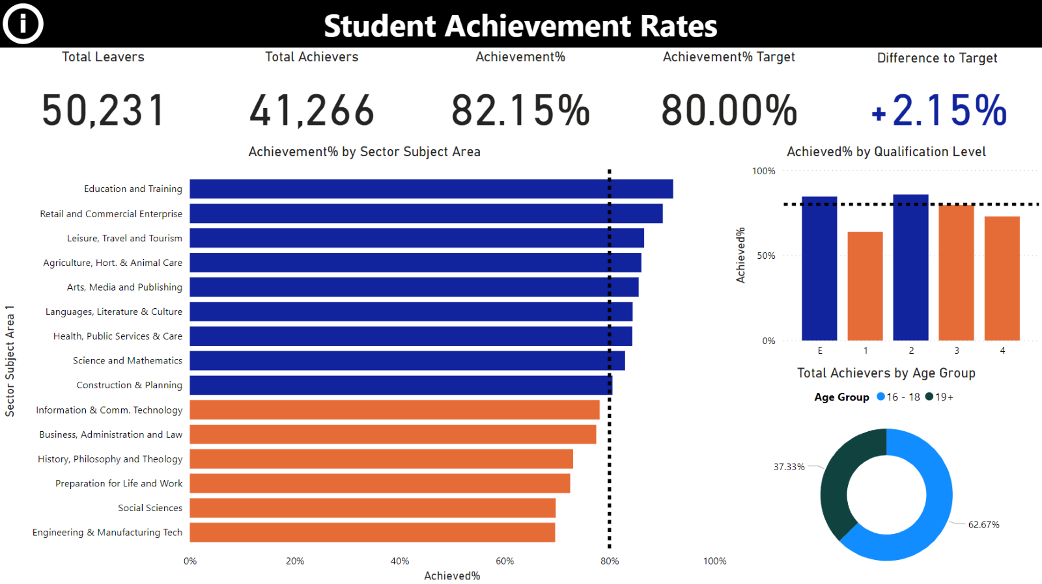

Figure 2, Student Retention Rates Page

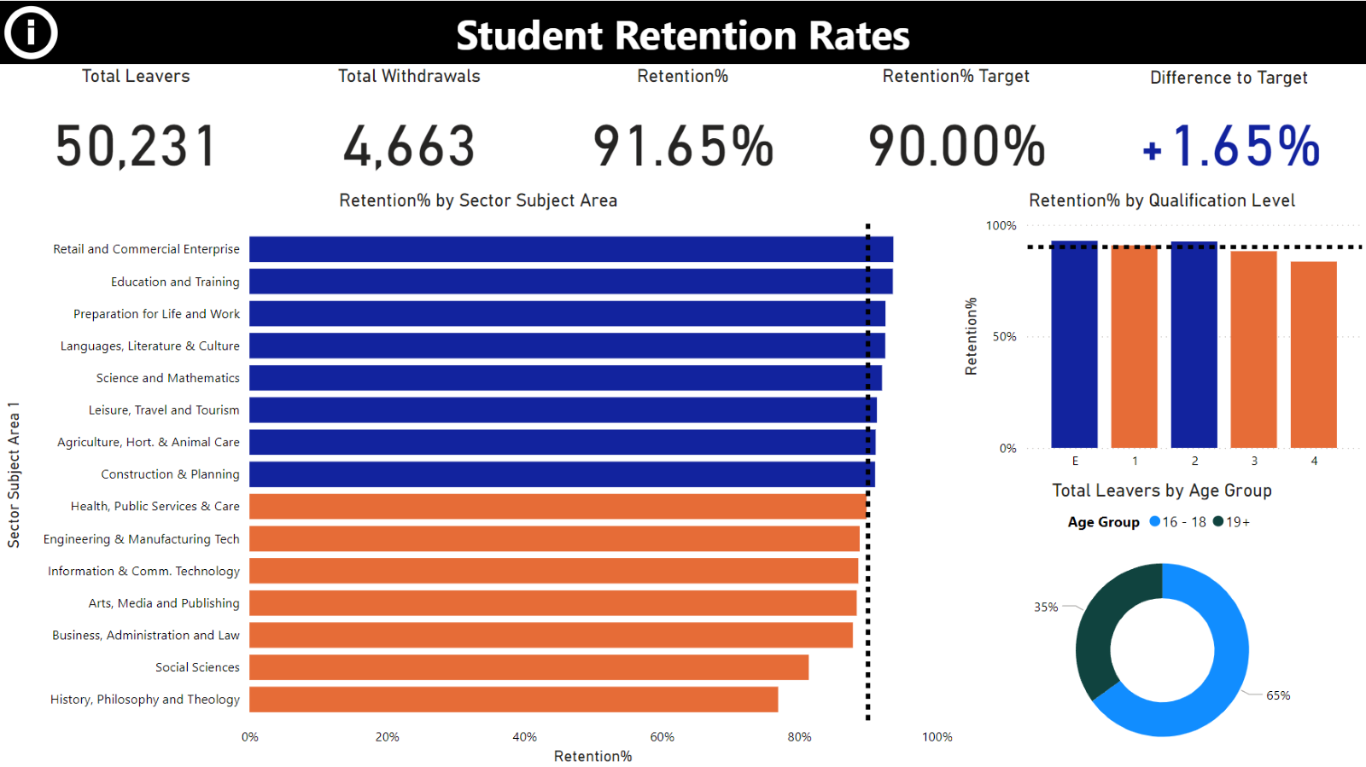

Figure 3, Leavers, Achievement, and Retention Trends Page

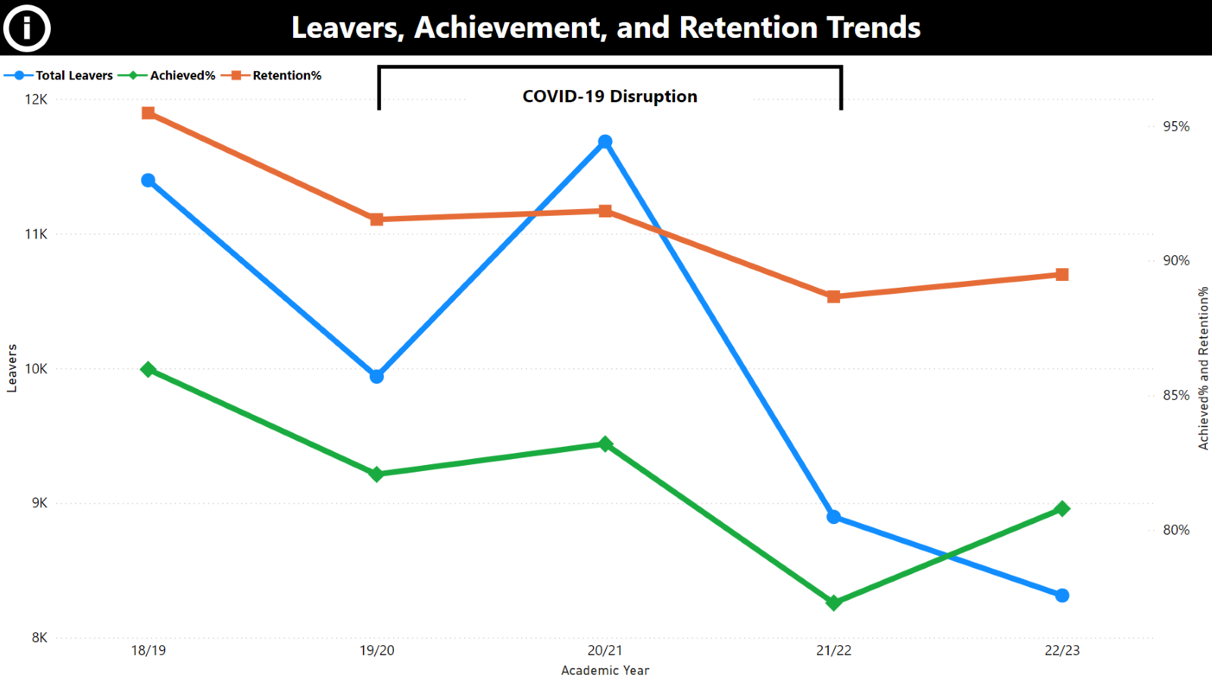

Figure 4, Achievement% by Sector Subject Area Chart in Focus Mode, Drilled Down on ‘Health, Public Services & Care’ Subject Area, With Tooltip

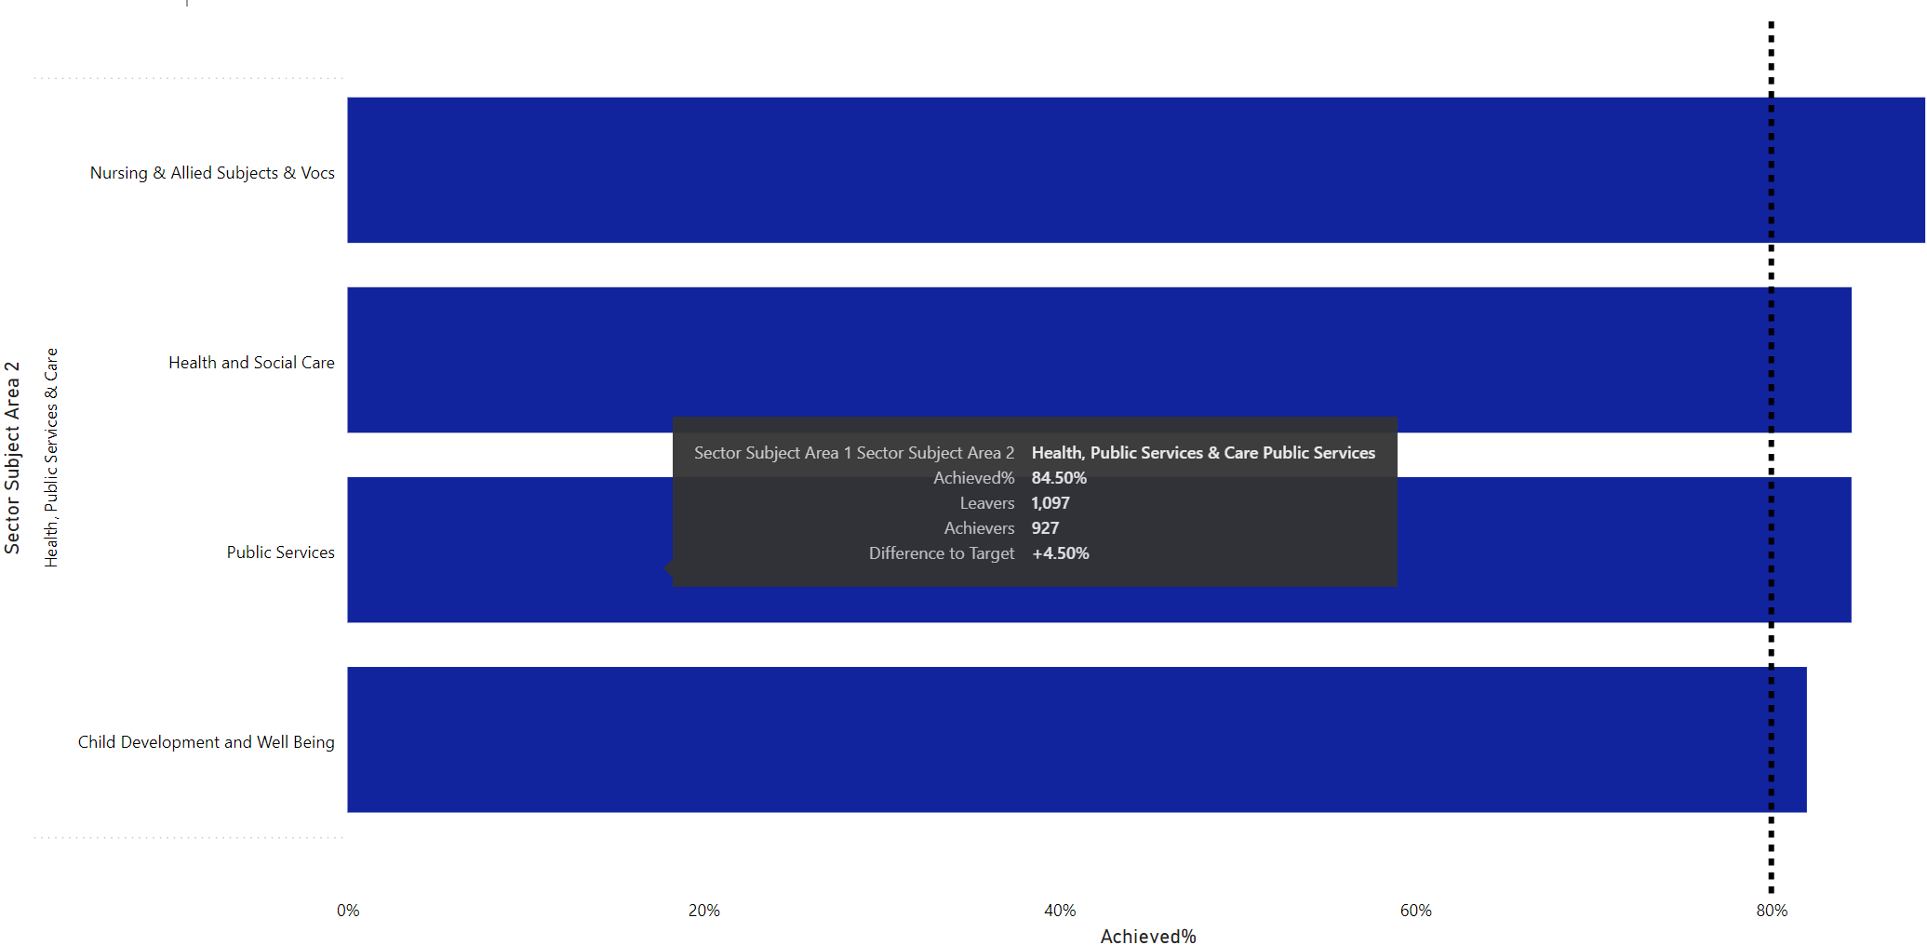

Figure 5, Total Achievers by Age Group, With Tooltip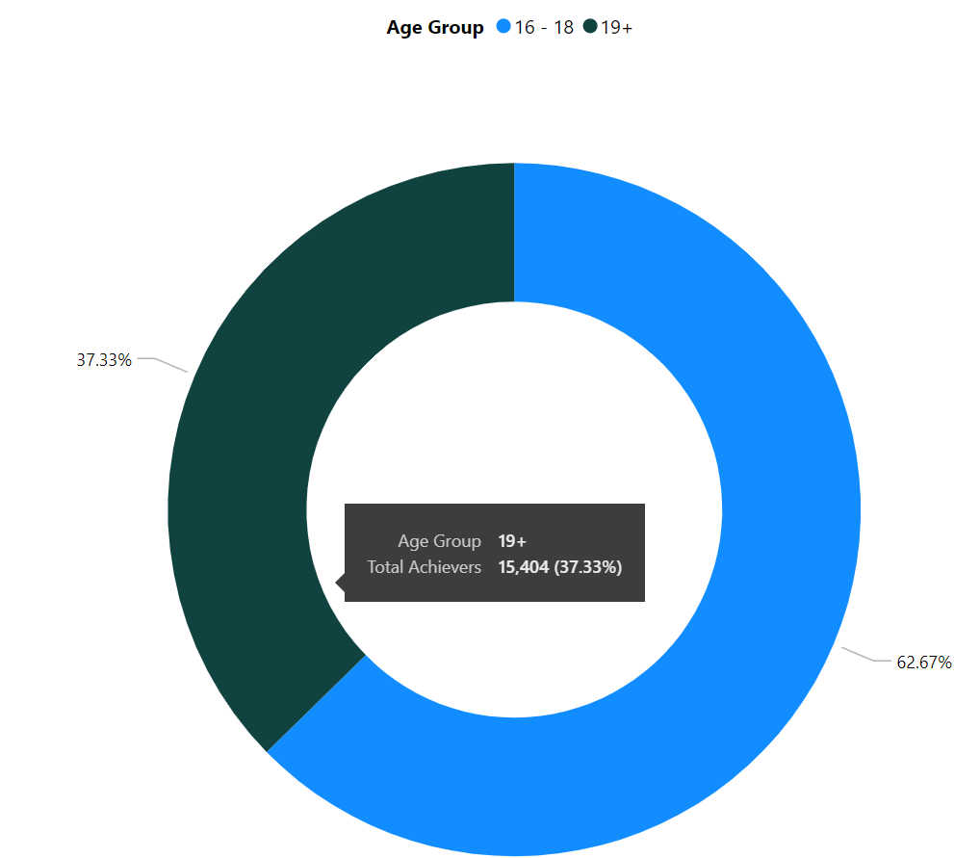

Figure 6, Student Achievement Rates Page Information Pane

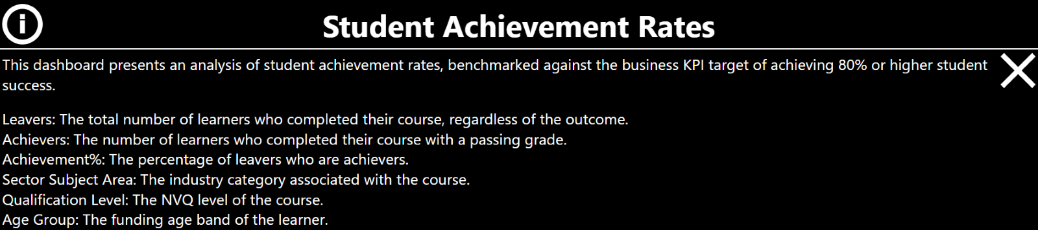

Figure 7, Student Retention Rates Page Information Pane

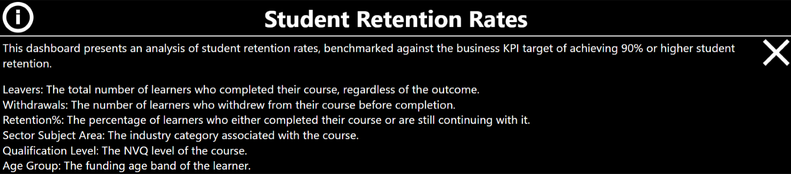

Figure 8, Leavers, Achievement, and Retention Trends Page Information Pane

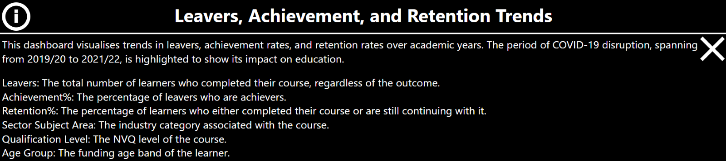

Figure 9, Alternative Text Example

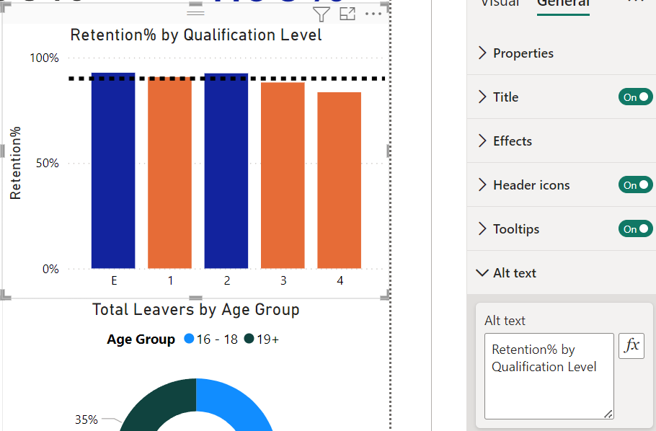

Figure 10, Performance Analyser Results

